Microsoft Office Specialist (MOS) Certificate Sample

Issued by CERTIPORT

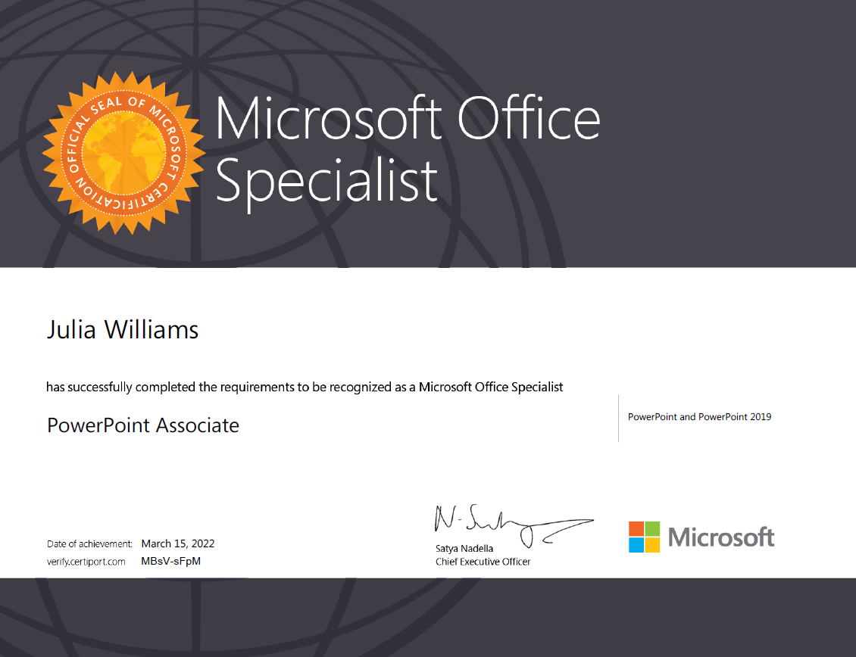
Sample Student

